Experiment: Magnetic field-Distance Relationship Time allocated: 45 min

Background Information:
The magnetic flux density ($B$) is the strength of a magnetic field at a point in space measured in teslas (T). Along the long axis of a bar magnet, the magnetic flux density can be determined using the following expression:
$$B=\frac{μ_{0}M}{2πd^{3}}$$
Where:
- $B is the magnetic flux density (T)$
- $μ_{0} is the magnetic constant (m kg s^{-2} A^{-2})$
- $M is the magnetic moment of the bar magnet$ ($N m T^{-1}$)
- $d is the distance from the middle of the bar magnet (m)$
$$d$$
Bar Magnet

The magnetic moment (M) of a bar magnet is a measure of the magnet’s intrinsic strength; it determines the force that the magnet can exert on other magnets. A larger magnetic moment indicates a stronger bar magnet.
The magnetic flux density for a bar magnet is proportional to $\frac{1}{d^{3}}$. The strengths of other types of fields in Physics covered in this course (gravitational and electrical) are proportional to $\frac{1}{d^{2}}$. Electric and gravitational fields can be produced from point source; a single point in space which can be considered as the source of the field (e.g. proton for electric fields or the centre of mass for a gravitational field). Magnetic fields are produced in a dipole arrangement; the separated N pole and S pole work together to produce the field. As long as the distance $d$ is significantly large compared to the length of the magnet, such that both poles contribute a similar amount to the magnetic field, this dipole arrangement is the reason why the flux density-distance relationship for magnetic fields is different to electric and gravitational fields of a point source.
The Experiment:
Students performed an investigation to check the relationship between the flux density and the distance from a bar magnet by using the following procedure:
- Place a magnet standing upright on a flat surface, with the N pole at the top.
- Have a student hold a ruler close to, but not touching, the top of the magnet, aligned vertically.
- Have another student use a magnetic probe to measure the flux density at the 10 cm mark of the ruler.
- Repeat step 3, increasing the distance each time.
Here is the students’ table of results:
Distance from top of magnet (m) | Distance from middle of magnet (m) | Magnetic flux density (mT)
0.060 | 0.100 | 170
0.080 | 0.120 | 100
0.110 | 0.150 | 50
0.140 | 0.180 | 30
0.180 | 0.220 | 16

Questions
- Produce a linear graph from the independent and dependent variables in the table, using the background information as a guide. You may need to adjust the data to ensure the graph is linear. You may fill in the blank column of the table to assist you. [7 marks]

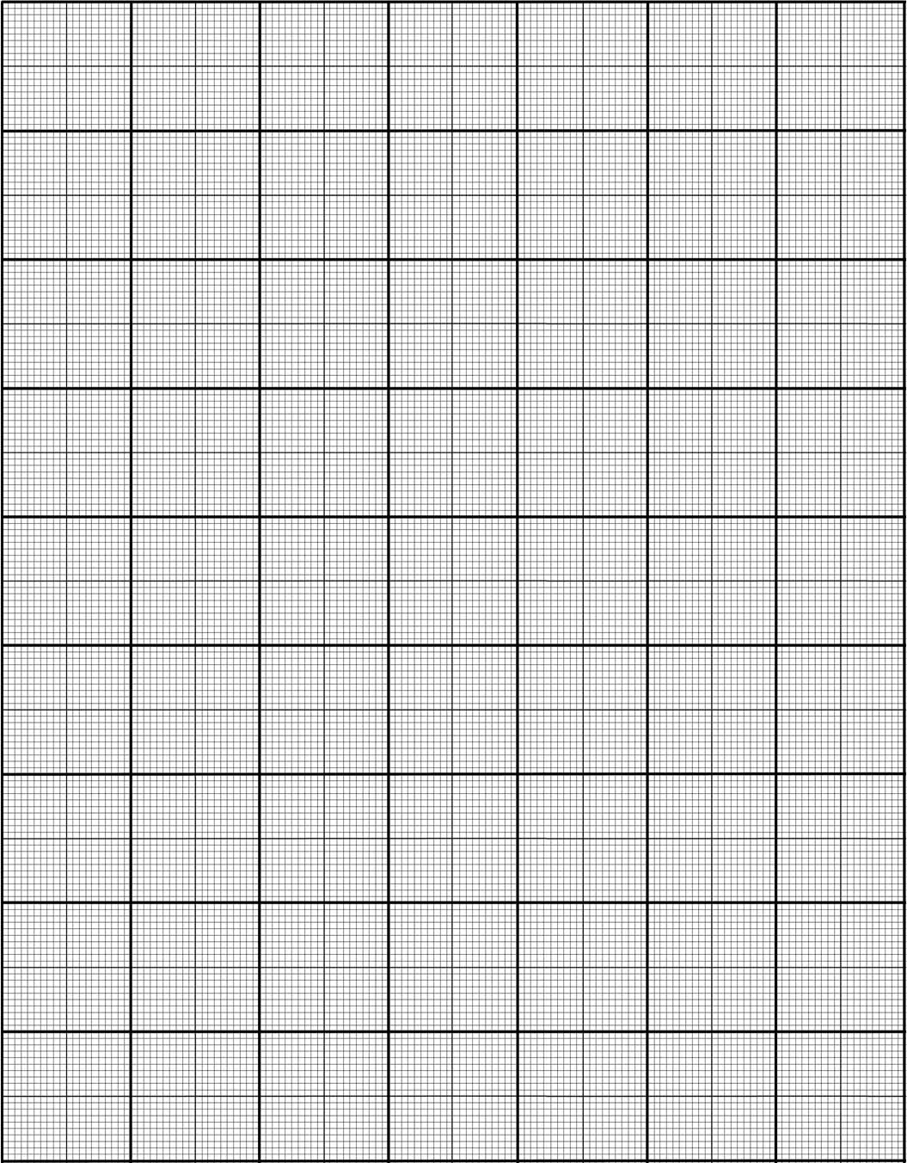

- Describe what knowledge has been gained by producing a linear graph from manipulated data, compared to plotting the raw results. [1 mark]

- From the graph, calculate the gradient of your line of best fit. Include units. [3 marks]

- Using the gradient, determine the magnetic moment of the bar magnet the students used in this experiment. [3 marks]

- The students repeated the experiment with a different bar magnet that had twice the magnetic moment of the original. Onto your graph, sketch the expected trend line that would be produced by using this new bar magnet. [2 marks]

- Based on the method the students followed and the data provided in the table, estimate the uncertainty of their distance measurements. Justify your estimation. [3 marks]

- The students had extra data which they left out of their table as it did not fit the expected trend. Here is a scale diagram of the equipment for this particular result.
Magnetic Flux Probe

Connected to data logger
1 cm
N

8 cm

S

The results obtained are below:
Distance from top of magnet (m) | Distance from middle of magnet (m) | Magnetic flux density (mT)
0.010 | 0.050 | 1700

  - Via a calculation, determine what the expected magnetic flux density is 1 cm above the magnet, as predicted by the other results of this experiment. Calculate the percentage difference between this expected result and the actual result taken from 1 cm above the magnet.
[3 marks]

  - This result is actually much closer to what would be expected if magnetic fields behaved the same way as electric and gravitational fields produced by a point source. Explain why. [3 marks]

